Computer Language Coding Concepts

Inheritance Main Concepts
The new computer language supports several forms of inheritance. All these basic forms of inheritance will be laid out in this article.

Class Inheritance
Class inheritance is the traditional form of inheritance: one class takes over all characteristicts of another class. This is displayed as follows:

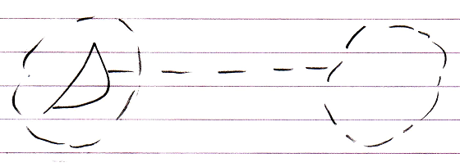

The second class merges with the first class. The first class has an interface that delegates its implementation to the second class.

Object Inheritance
An object can merge with another object, delegating its interface, implementation and its values to another object:

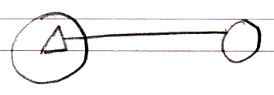

So this time the interface has an object line. This means that as soon as the other object’s values change, the derived object is automatically also changed. The other way around is also true: when you change the derived object’s inherited members, the base object also changes. Changes are not applied from one to the other: both are just references to exactly the same object: if the base object changes, the base of the derived object is also changing.

System Inheritance
Sites, computer programs and libraries can also inherit from eachother. This is because these modules are objects just like anything else in the new computer language. Modules inheriting fom eachother is called system inheritance.

The basic notation of system inheritance is:

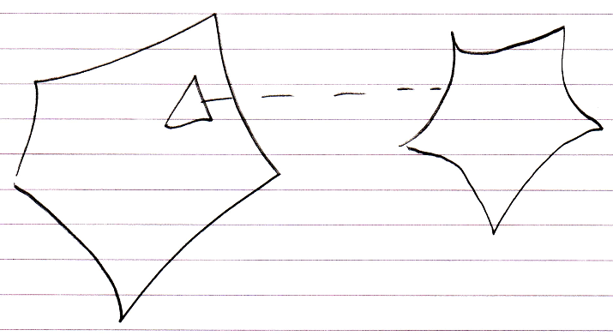

The example above is system class inheritance.
You can also use system object inheritance.

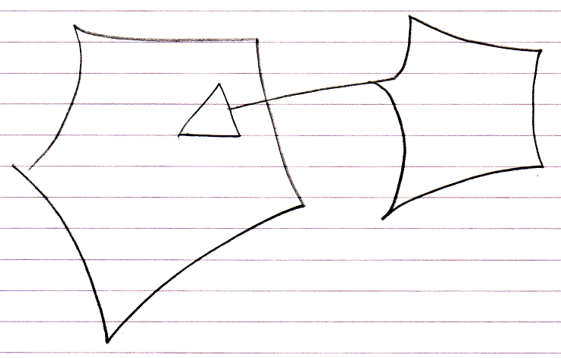

The difference between the two is completely analogus to class inheritance and object inheritance. In system class inheritance the derived system’s values can be reconfigured without affecting the base system. In system object inheritance the derived system can not reconfigure the values of the base system: if values are changed, the base system itself is changed. Just see it as working directly on the base system.

A technique that should be mentioned, that is particularly applicable to system inheritance, is deeper specialization. Specialization techniques will be gone into later, but deeper specialization allows you to specialize behavior not only of the direct members of a system but also specialize members much deeper into the system.

List Inheritance
List inheritance is a special form of inheritance where one list inherits from another.

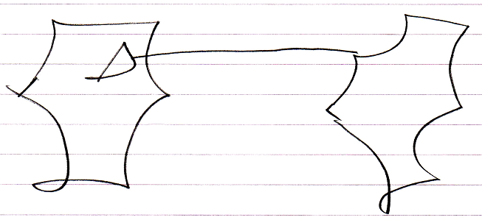

What is special about it, is that when an object is added to the base list, an object is also added to the derived list.

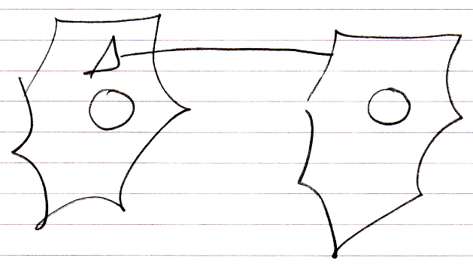

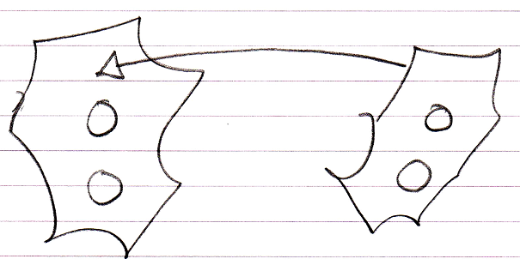

And the list item added to the derived list will inherit directly from the list item in the base list.

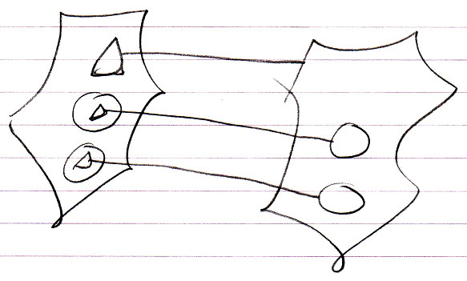

List inheritance is analogus to defining a parallel list, adding extra columns to an existing list.

This behavior is specific to list inheritance and does not apply to any of the other forms of inheritance.

The list inheritance construct realizes such behavior by responding to the List events of the base list: the Added and Removing events. These events are system events, that were introduced by the Events chapter.

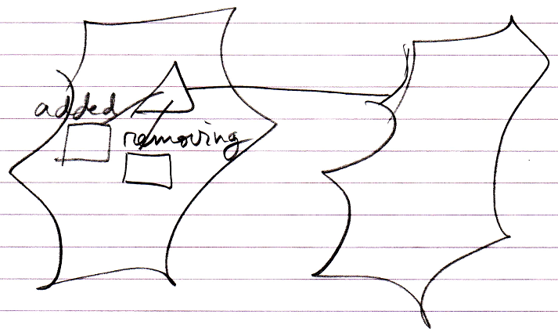

These events make sure that what happened in the base list, will also happen in the derived list.

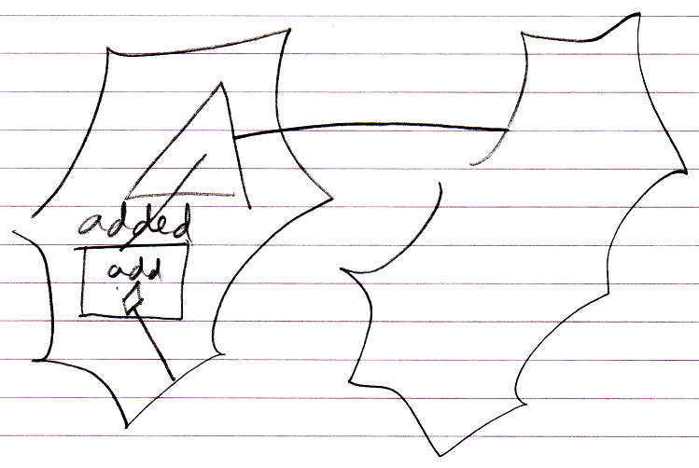

And on top of that, the derived list item will be linked to the base list item through inheritance.

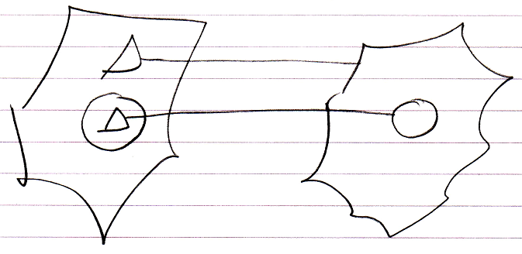

List inheritance also makes a distinction between object inheritance and class inheritance. The default is object inheritance, which causes the behavior you are most likely to expect.

But class inheritance is also possible for lists, in case of which the lists items will be linked with class inheritance:

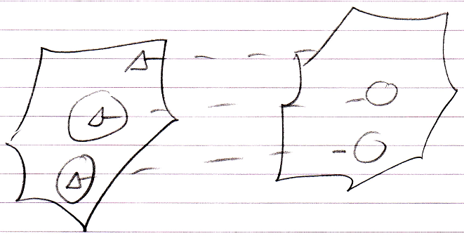

This behavior is not as intuitive as object list inheritance.

For an explanation about how different list objects themselves, such as linked list and stack, can inherit from eachother, see the article List Concept.

The following might be something you could get confused about. A normal object is also a list of members. However one object’s inheriting from another object does not cause the same behavior as list inheritance: extra members are not added to the derived object when members are added to the base object. So do not get confused over this.

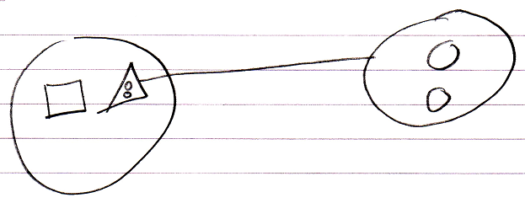

Interface Inheritance
Since any redirection of a triangle is considered inheritance, interface redirection of a triangle may also be called inheritance: interface inheritance.

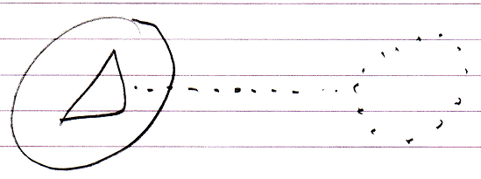

So the main concepts of inheritance are basically the same as interfaces. However, the extra that comes with inheritance is specialization.

Author & Copyright: Jan-Joost van Zon Date: May 18, 2010 – May 31, 2010 Location: Oosterhout, The Netherlands Status: Finished

